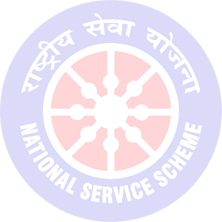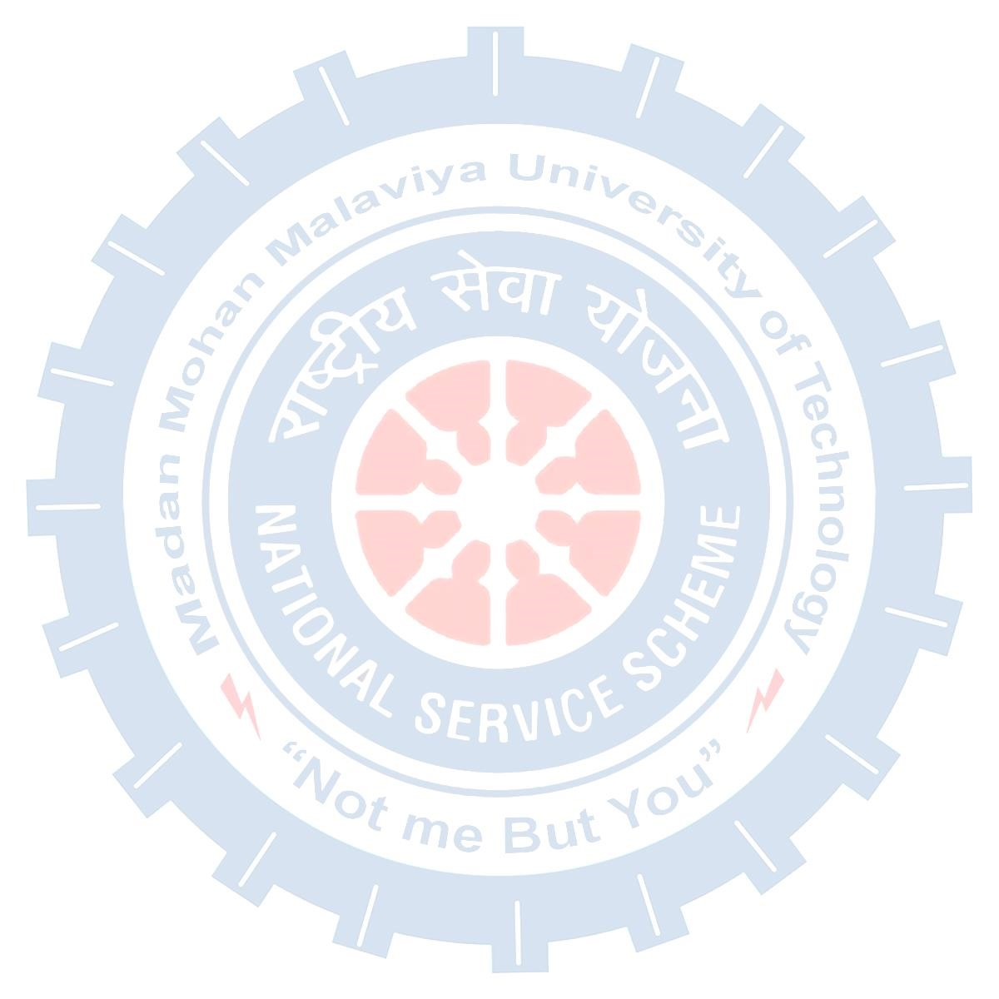

**MADAN MOHAN MALAVIYA UNIVERSITY OF TECHNOLOGY**

**GORAKHPUR, UTTAR PRADESH (INDIA)**

**273 010**

**.**

**Office of Dean of Student Affairs (DSA)**

**National Service Scheme (NSS) Cell**

nss20.mmmut@gmail.com

@nss_mmmut

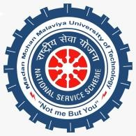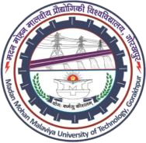

**REPORT**

**Pararth;** A donation drive to bring about the feeling of giving and to help those in need. Pararth was event dedicated to upholding its motto “Incredible Donation, Incredible You” and raising the sense of charity in individuals. It was conducted from April 14th to May 14th, 2021, where unused clothes, stationery, and sports good were donated through various drop stations and cloth bank was organized near the NSS office. The event was praised by everyone and was endorsed by various dignitaries of Gorakhpur like Mayor, District Collector etc.

Number of students participated: 3577

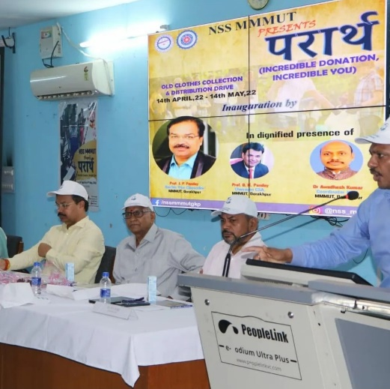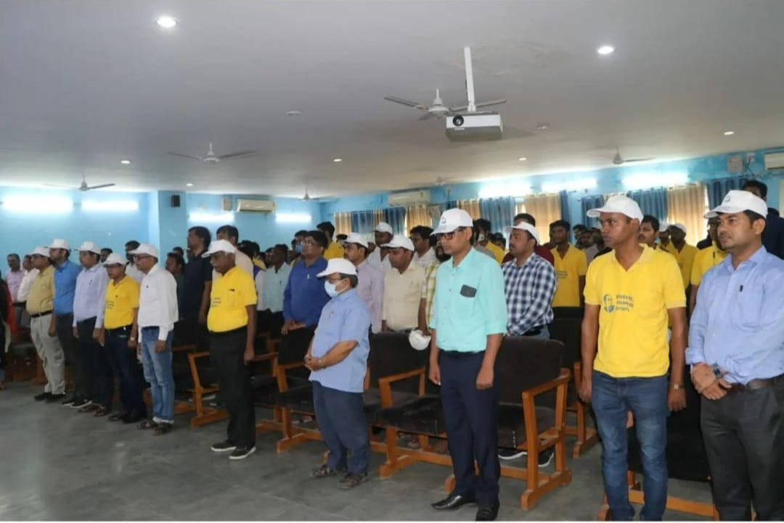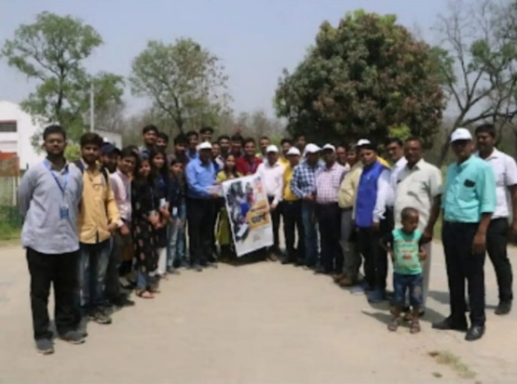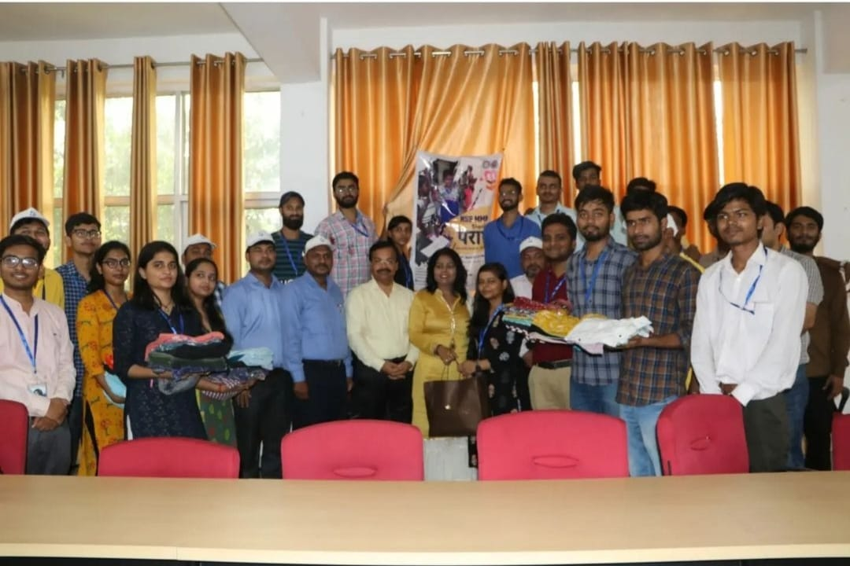

**Aayansh and Unity Day Celebration;** On 31st October 2021, NSS Unit of MMMUT had organized two events, first was an oath swearing ceremony on the occasion of National Unity Day to reinforce and strengthen the unity of our nation in which the Chief guest was Prof. J.P. Pandey (hon’ble Vice chancellor) and guest of honor was Mrs. Saroj Pandey (Chairman University Women’s Club), Prof. Govind Pandey (Dean of Planning, Resource Generation and Alumni Affairs).

This program was conducted under the supervision of Dr. B.K. Pandey (CSA Chairman) and



**MADAN MOHAN MALAVIYA UNIVERSITY OF TECHNOLOGY**

**GORAKHPUR, UTTAR PRADESH (INDIA)**

**273 010**

**.**

**Office of Dean of Student Affairs (DSA)**

**National Service Scheme (NSS) Cell**

nss20.mmmut@gmail.com

@nss_mmmut



Dr. Awadhesh Kumar (NSS Coordinator). Second event was Diwali celebration which was celebrated in a special way with the kids of Malaviya Shiksha Niketan. We believe that happiness increases by sharing. So, we distributed more than 200 notebooks and stationary items to bring delight and rejoice on their faces.

Number of students participated: 225

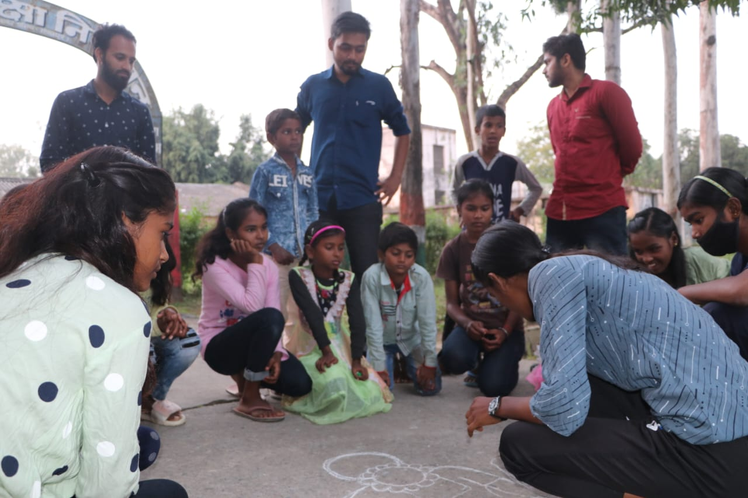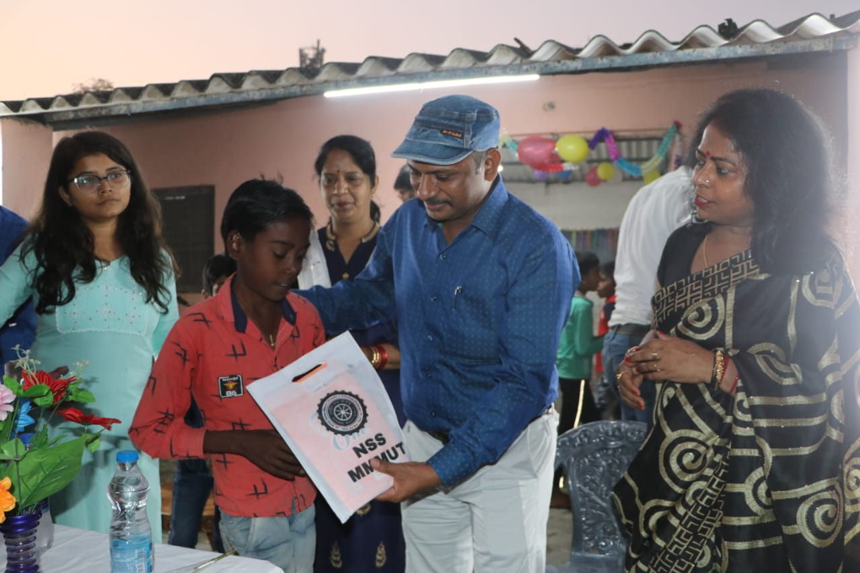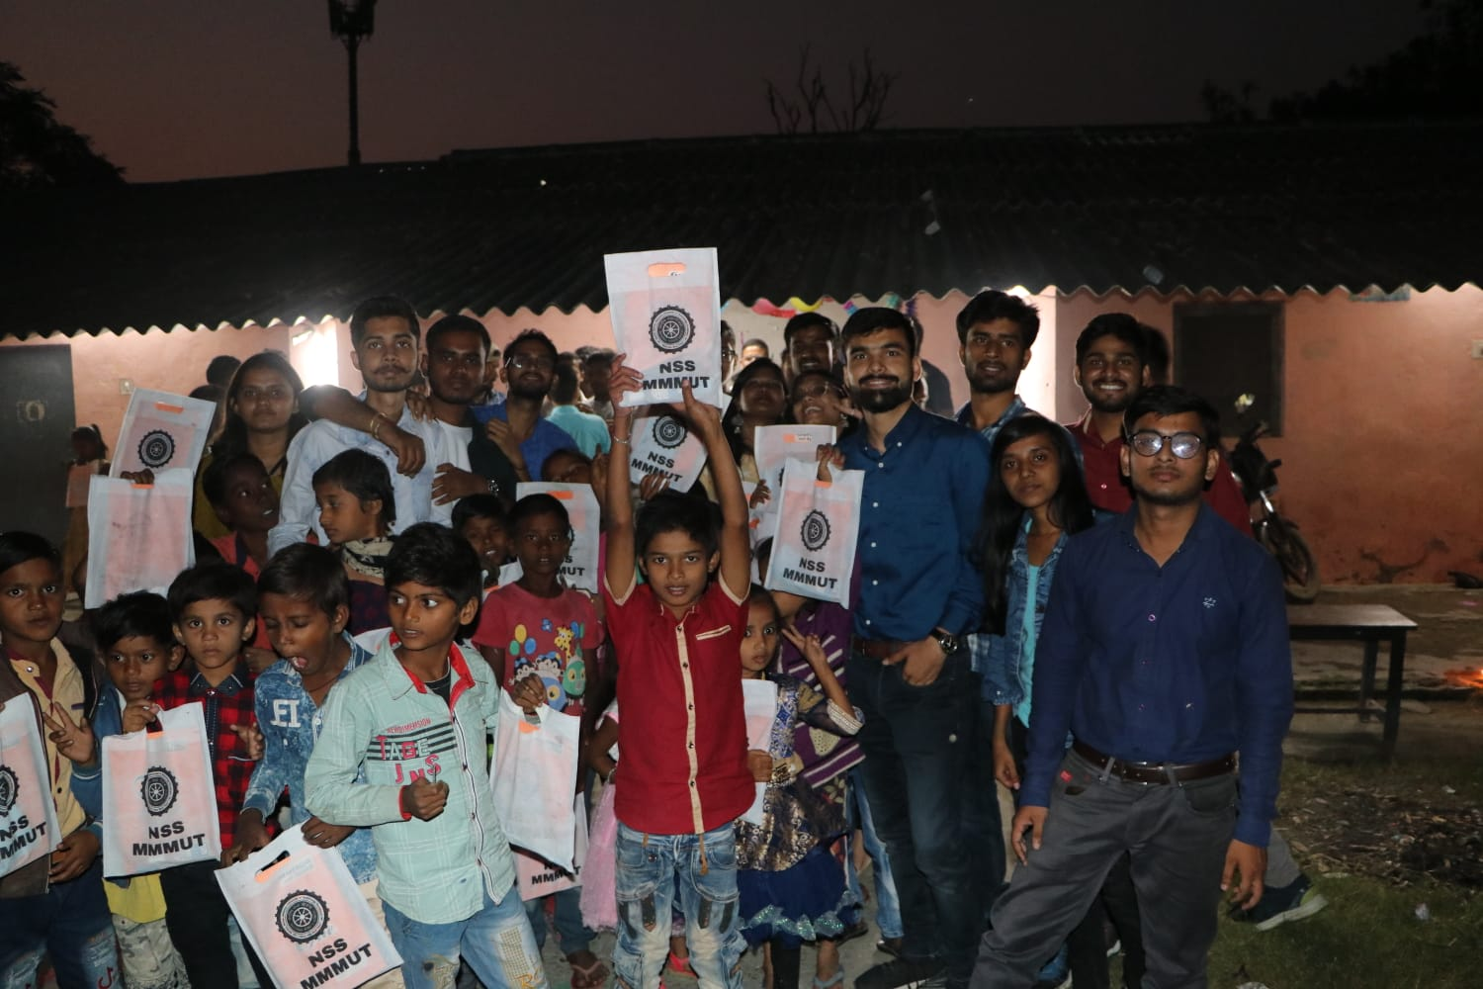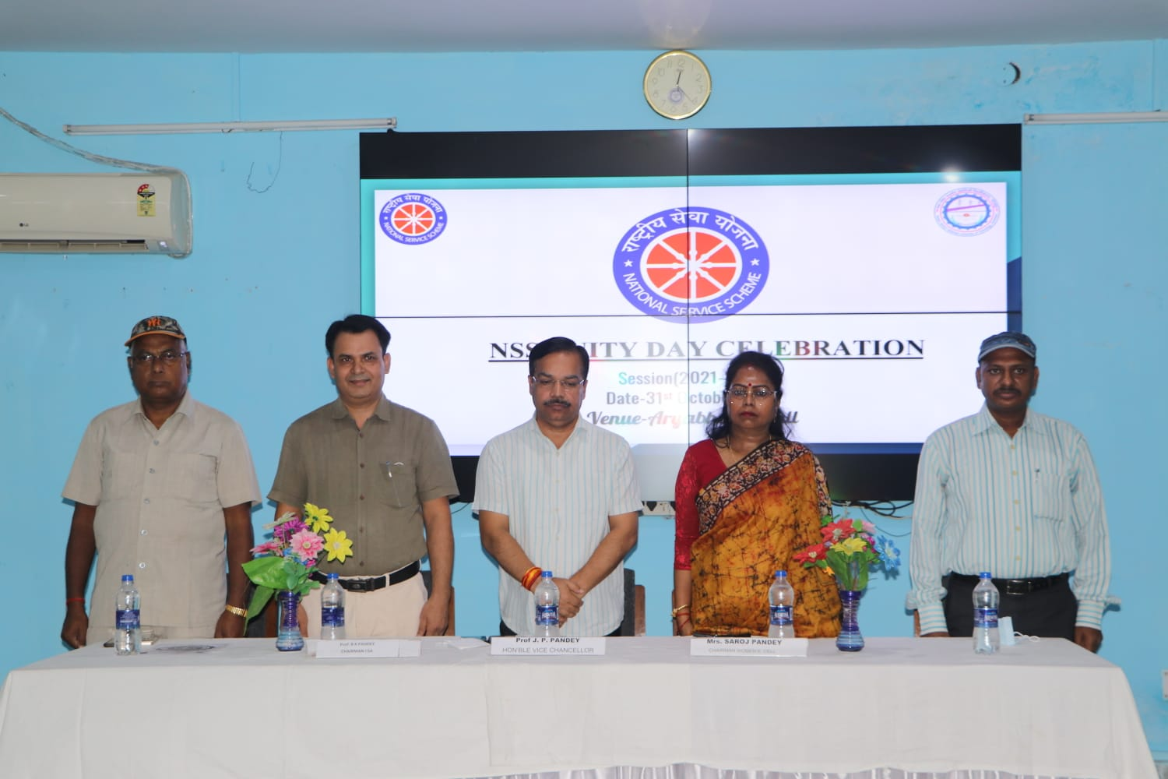

**Blood Donation:** A great initiative of organizing annual blood donation camp was taken by NSS Unit of Madan Mohan Malaviya University of Technology, Gorakhpur on 30 December ,2021 under the supervision of Dr. Awadhesh Kumar (NSS Coordinator). A donation card and refreshment were given to the doner as a token of gratitude. Over whelming response was recorded, and more than 70 units of blood was donated.

Number of students participated: 105



**MADAN MOHAN MALAVIYA UNIVERSITY OF TECHNOLOGY**

**GORAKHPUR, UTTAR PRADESH (INDIA)**

**273 010**

**.**

**Office of Dean of Student Affairs (DSA)**

**National Service Scheme (NSS) Cell**

nss20.mmmut@gmail.com

@nss_mmmut



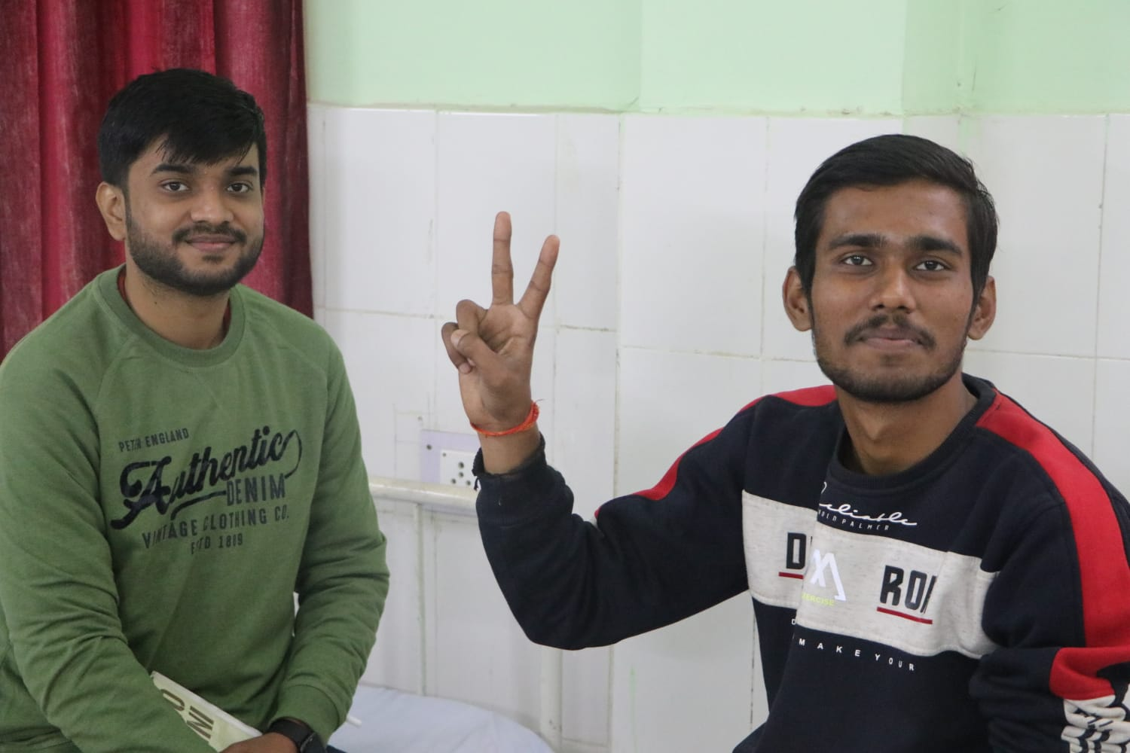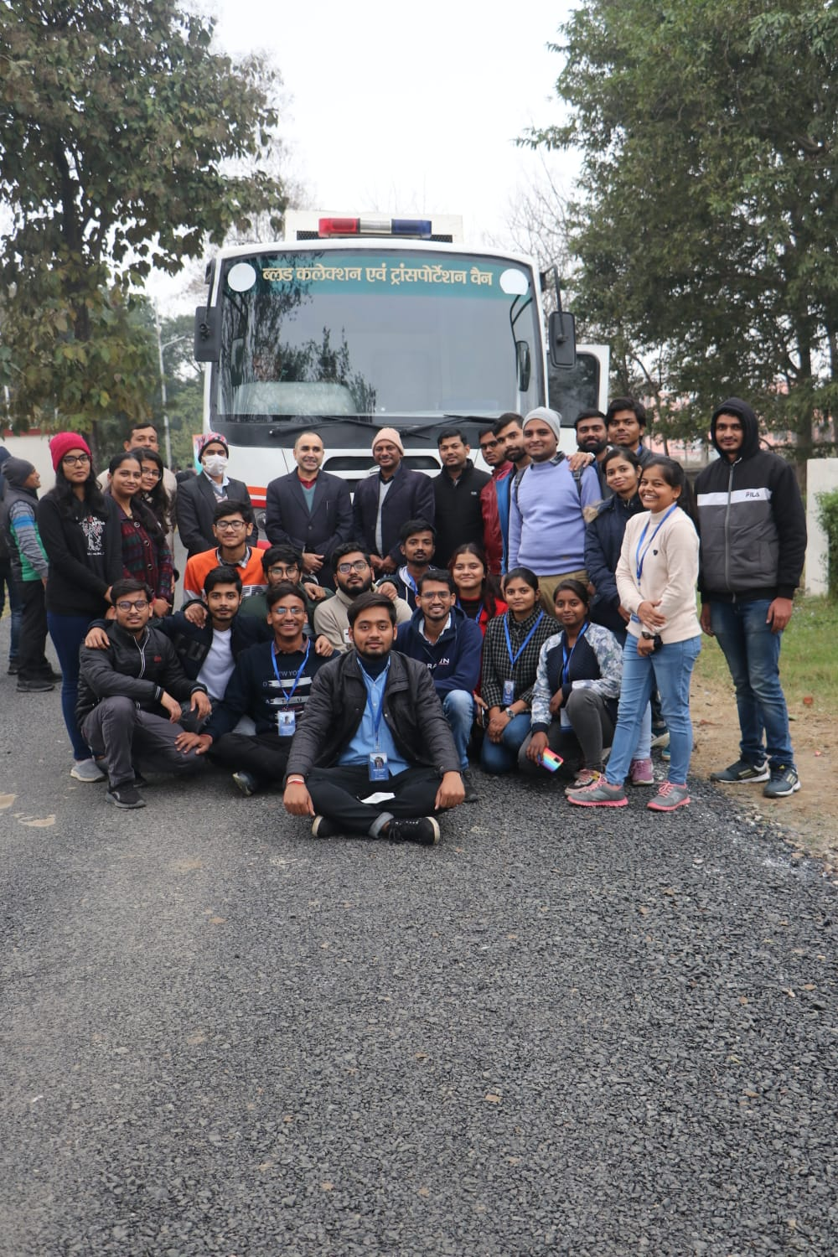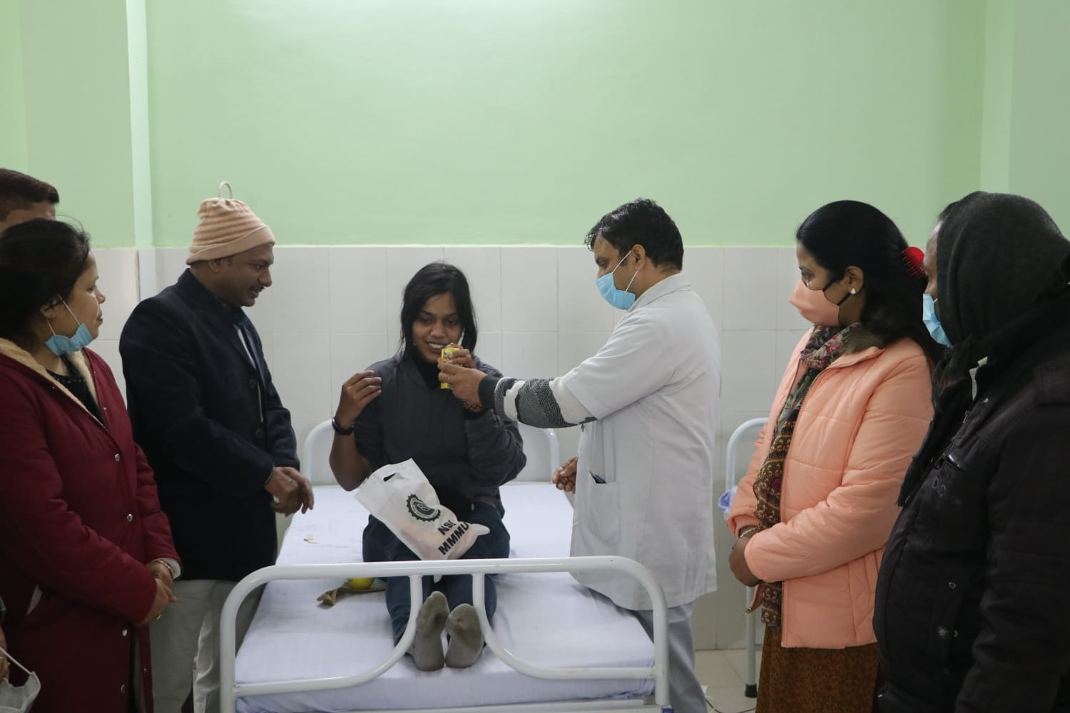

**Swaraj:** NSS MMMUT hosted an event Swaraj to commemorate the immortality of our wonderful heritage of freedom fighters. The event dedicated to reviving and celebrating the work and contributions of our unsung heroes. It consisted of 2 rounds 1st was quiz round and second was buzzer round.

Number of students participated: 1150

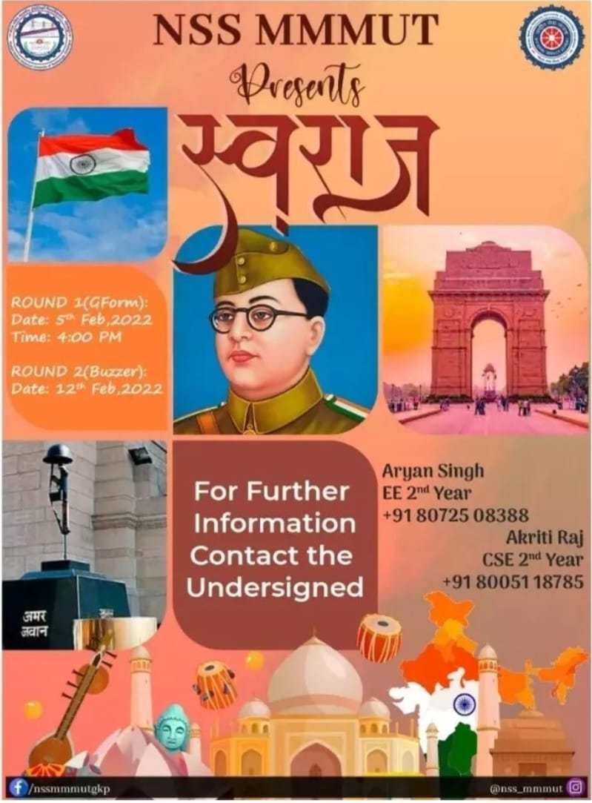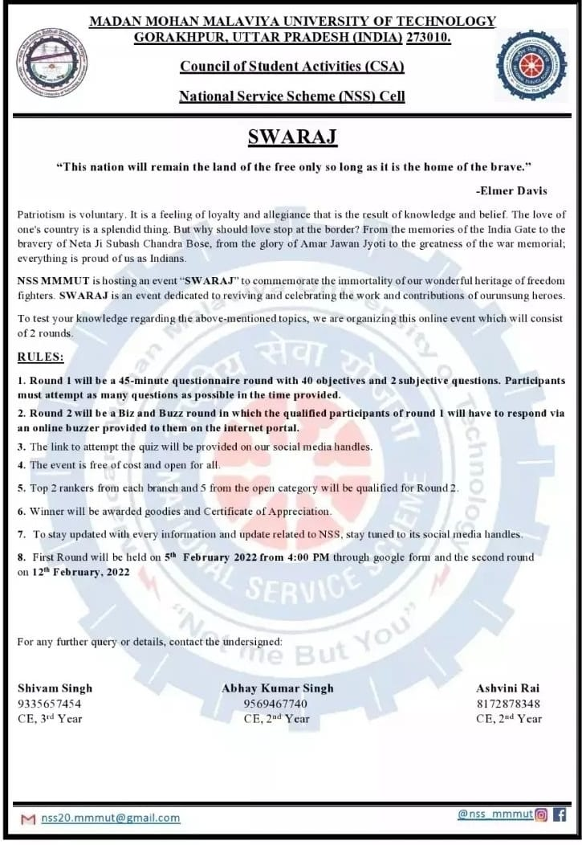



**MADAN MOHAN MALAVIYA UNIVERSITY OF TECHNOLOGY**

**GORAKHPUR, UTTAR PRADESH (INDIA)**

**273 010**

**.**

**Office of Dean of Student Affairs (DSA)**

**National Service Scheme (NSS) Cell**

nss20.mmmut@gmail.com

@nss_mmmut



**Webinar on Adverse Effect of Poor Mental Health:** The webinar was on May 29, 2022,

and speaker of the webinar was Dr. Sandeep Atre (Counselling Psychologist, Emotional &

social Intelligence Expert, Founder of “SOCIALIGENCE”, Author of 2 Books). It was all

about developing awareness in recognizing signs and symptoms when we are feeling off and

be more aware about the adverse effect of poor mental health in students’ life.

Number of students participated:150

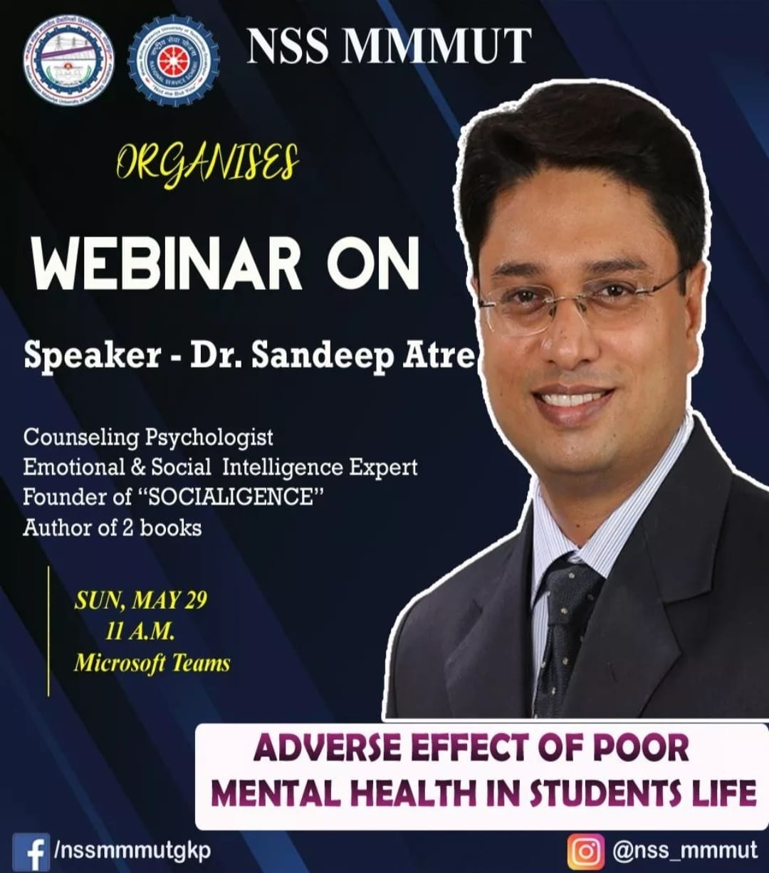

**Webinar on Challenges Due to Mental Disturbance:** The webinar was on June 12, 2022,

and speaker of the webinar was Mamta Pandya (Entrepreneur, Motivational speaker, Faculty

at Art of Living). She taught us that psychological, emotional, and social wellbeing impacts

every area of our life. Having positive mental health allows us to effectively deal with the

daily stressors of life.

Number of students participated: 152

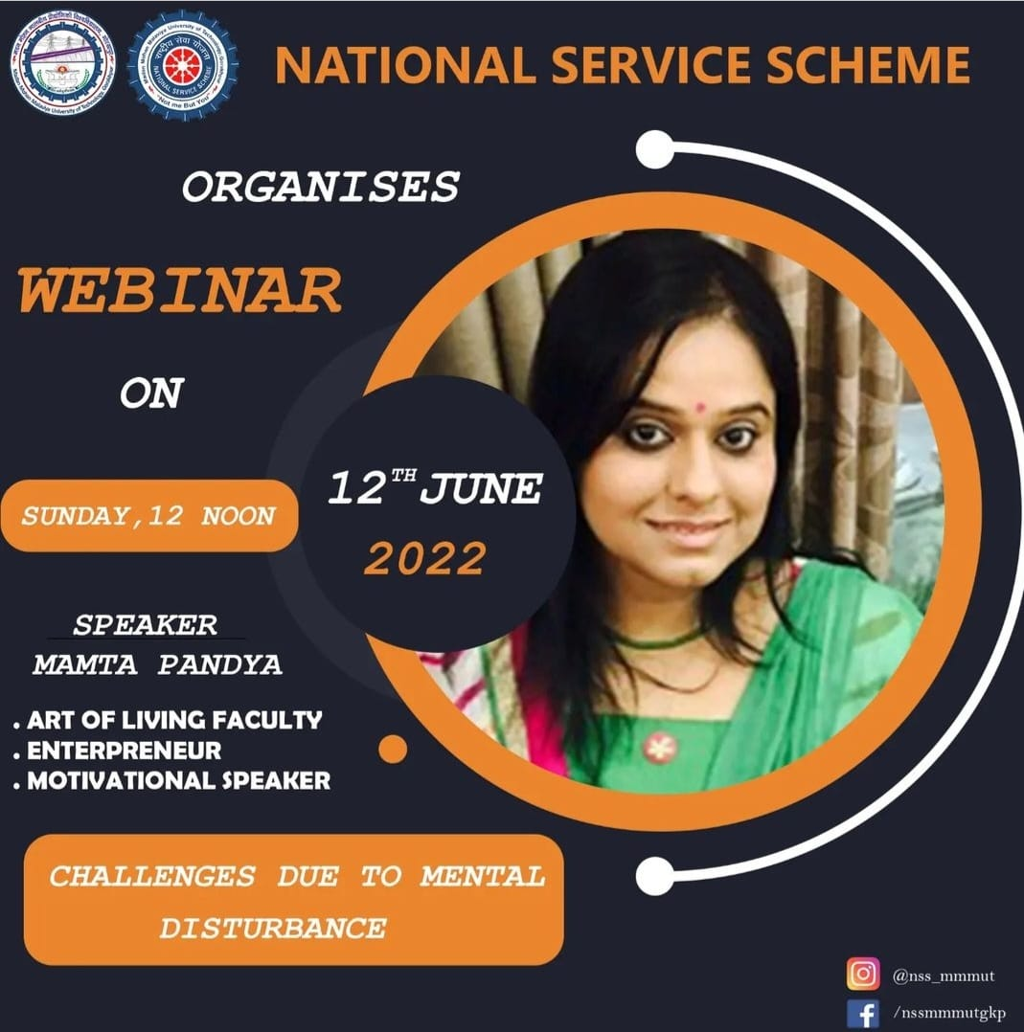



**MADAN MOHAN MALAVIYA UNIVERSITY OF TECHNOLOGY**

**GORAKHPUR, UTTAR PRADESH (INDIA)**

**273 010**

**.**

**Office of Dean of Student Affairs (DSA)**

**National Service Scheme (NSS) Cell**

nss20.mmmut@gmail.com

@nss_mmmut



**Chauri Chaura Visit;** National Service Scheme Unit, Madan Mohan Malviya University of Technology completed the campaign of Tricolour in every house under the Amrit Mahotsav of Independence National Service Scheme Coordinator Dr. Awadhesh Kumar started the program by hoisting the tricolour on the bus. On reaching the Chauri-Chaura incident site, the unit garlanded the statues of the martyred freedom fighters. After this, flowers were offered at the Chauri-Chaura Martyr's Memorial. Finally, Dr. Awadhesh Kumar presented the tricolour to Sunita Gupta, Chairperson of Chauri-Chaura Municipality.

Thereafter, the unit went to one of the villages adopted by the university, Dumri Khurd, where meeting the village head at the Panchayat Bhawan, he was given the tricolour and some part of the clothes donated in charity. Professor Pradeep Mule, Rohit Kumar, Sunil Yadav, Dhirendra Singh, Abhishek Gupta, Ram Kewal, Abhijeet Mishra, Bijendra Pushkar, Ugrasen Sonkar, program officer and security in-charge Ashok Mishra were present on the occasion.

Number of students participated: 110

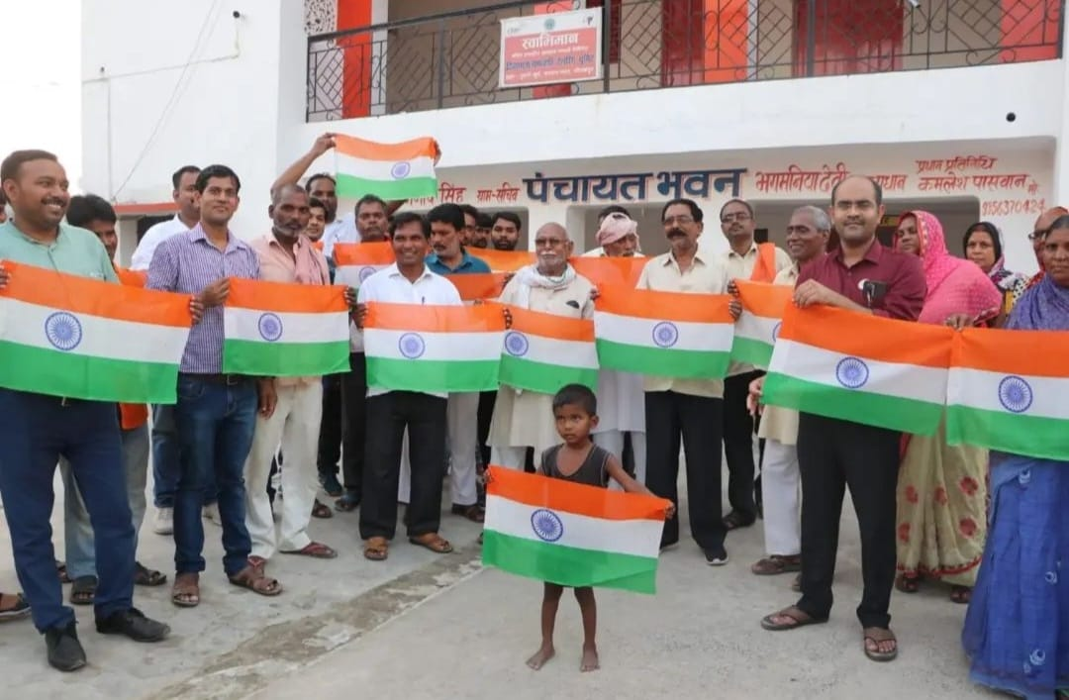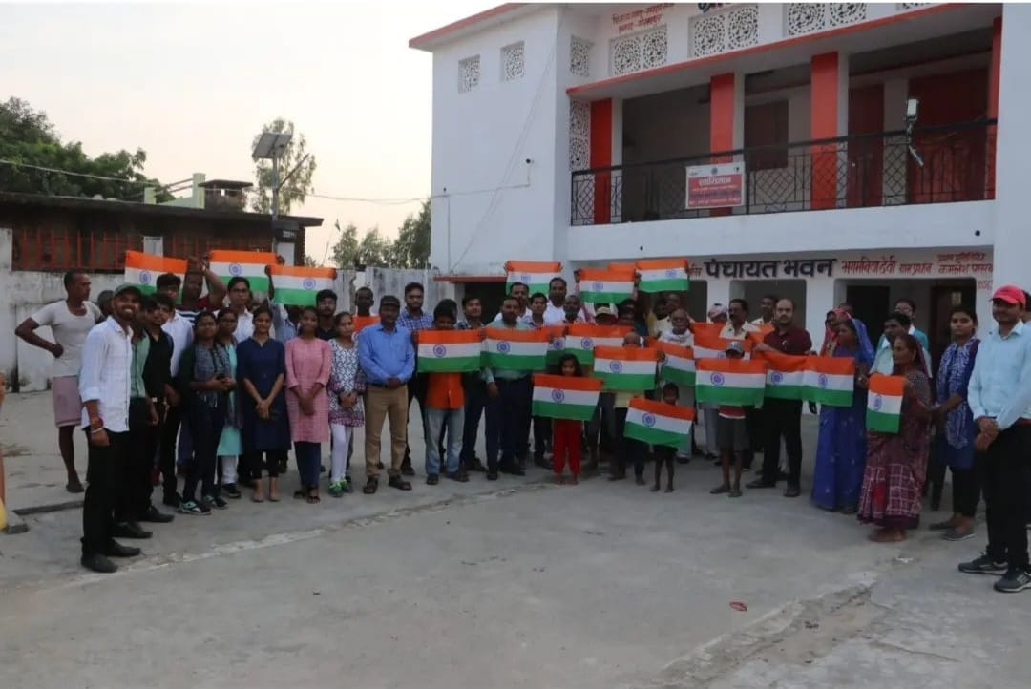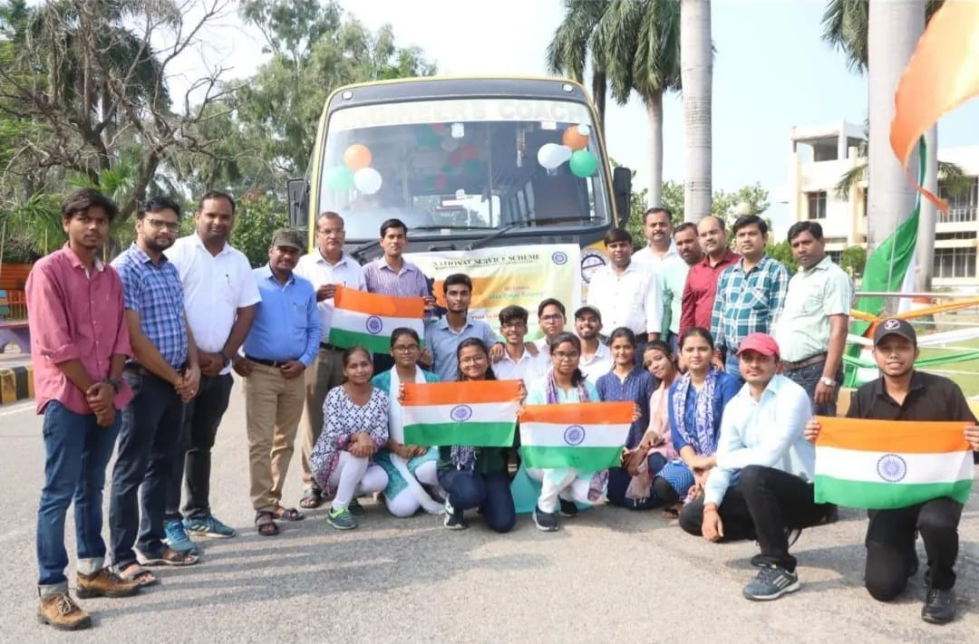

**Swacchata Abhiyan;** Every moment is a fresh new beginning. National Service Scheme, MMMUT had started an event named Swaccha Bharat Abhiyan to celebrate Azadi ka Amrit Mahotsav, whose inauguration was done by the Hon'ble Vice Chancellor Prof. J. P. Pandey at Aryabhata Hall, ITRC.

On this occasion, Vice Chancellor of MMMUT Gorakhpur administered the oath of cleanliness to all the people and inspired people to spread awareness about cleanliness.

Number of students participated: 237



**MADAN MOHAN MALAVIYA UNIVERSITY OF TECHNOLOGY**

**GORAKHPUR, UTTAR PRADESH (INDIA)**

**273 010**

**.**

**Office of Dean of Student Affairs (DSA)**

**National Service Scheme (NSS) Cell**

nss20.mmmut@gmail.com

@nss_mmmut



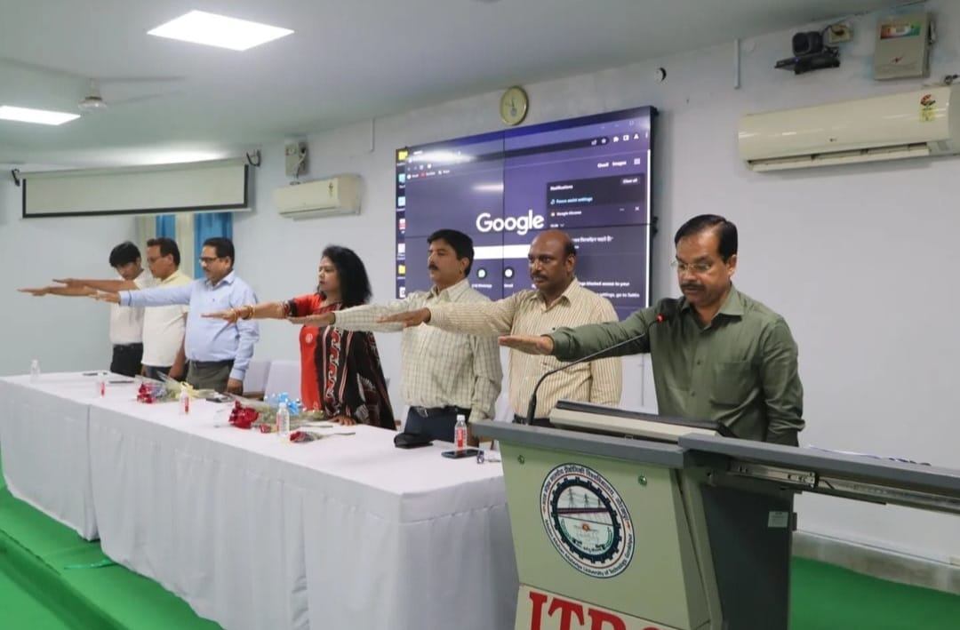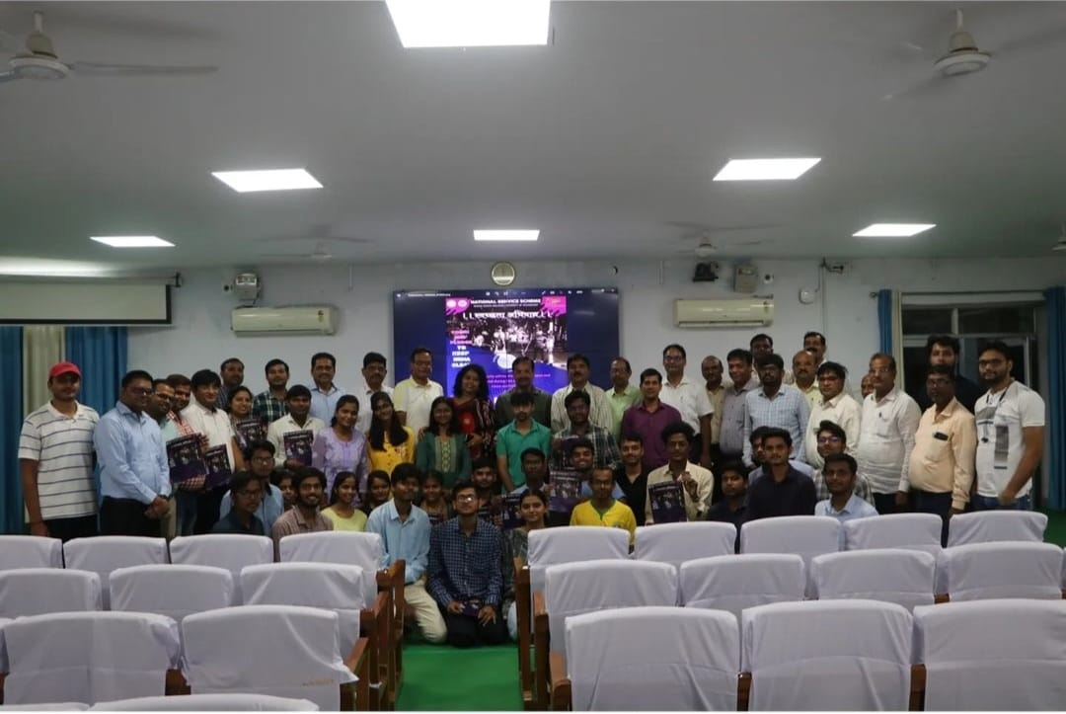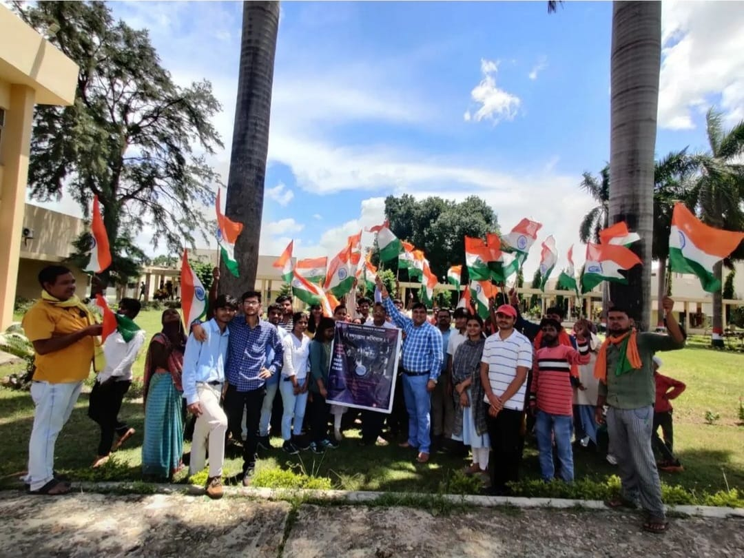

|  |  |  |
| --- | --- | --- |
| **Name of the activity** | **Year of the activity** | **Number of students participated in such activities** |
| Unity Day Celebrations | **2021** | **164** |
| AAYANSH | **2021** | **225** |
| Annual Blood Donation Camp | **2021** | **105** |
| SWARAJ | **2022** | **1150** |
| PARARTH | **2022** | **3577** |
| Webinar on Adverse Effect of Poor Mental Health in Students Life | **2022** | **150** |
| Webinar on Challenges due to Mental Disturbance | **2022** | **152** |
| Swachh Bharat Abhiyan under | **2022** | **237** |
| Chauri Chaura Visit | **2022** | **110** |

**Dr. B.R. Ambedkar’s Jayanti**

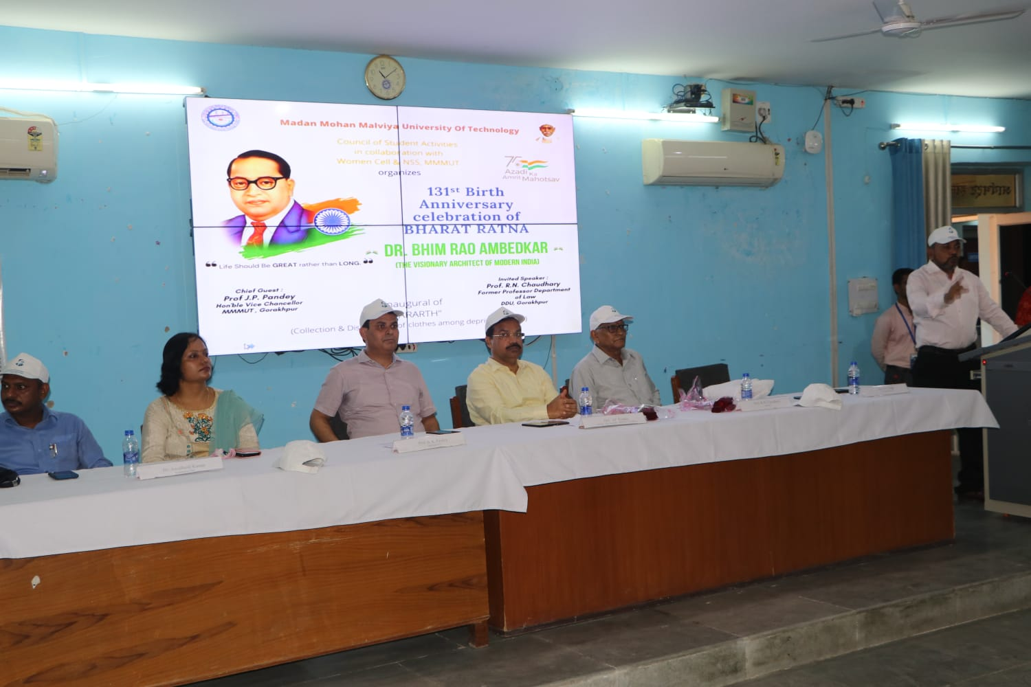



Plantation of Trees

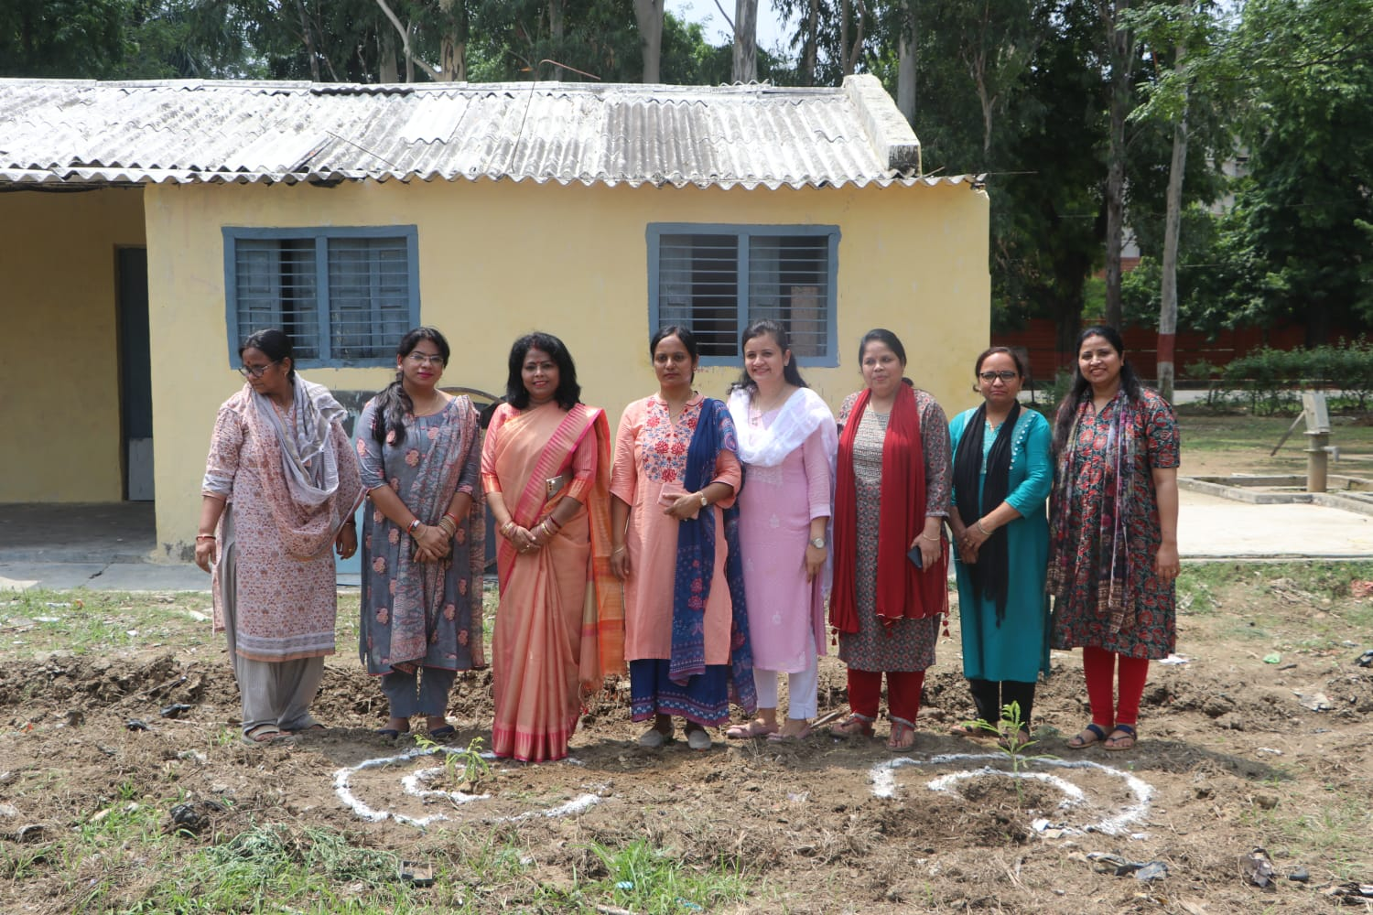

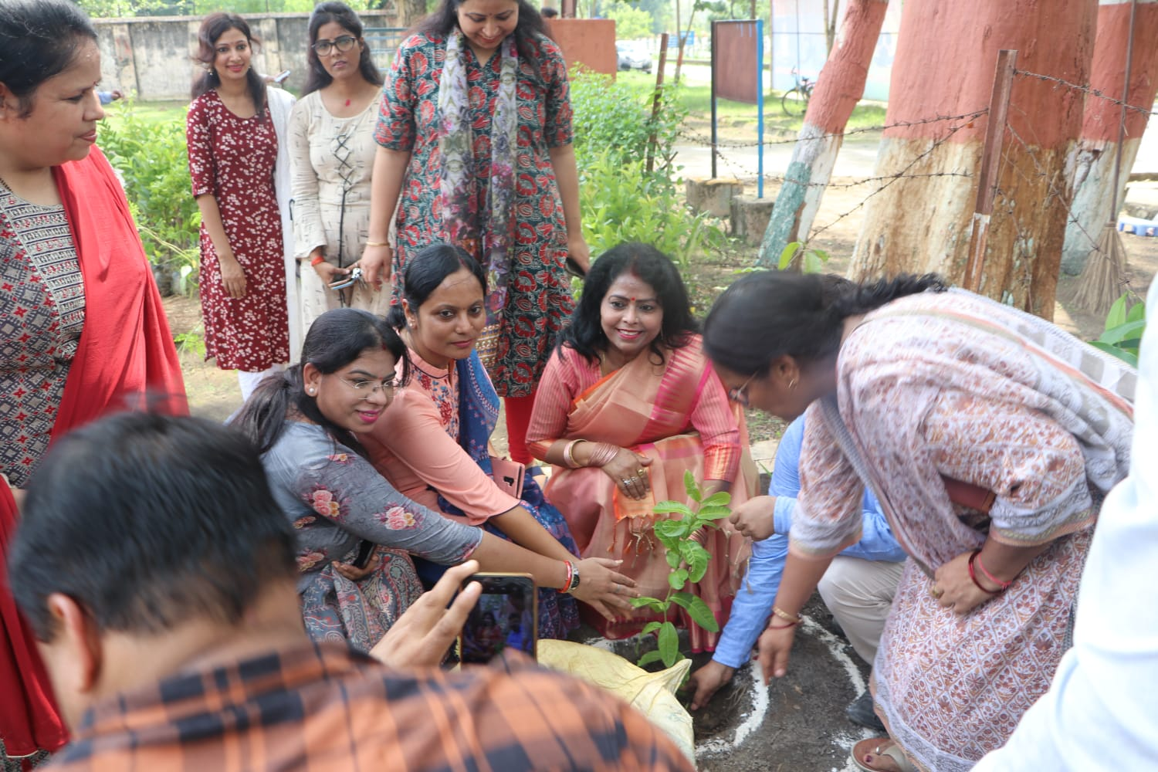

Independence Day

