**MADAN MOHAN MALAVIYA UNIVERSITY OF TECHNOLOGY GORAKHPUR, (U.P.), INDIA**

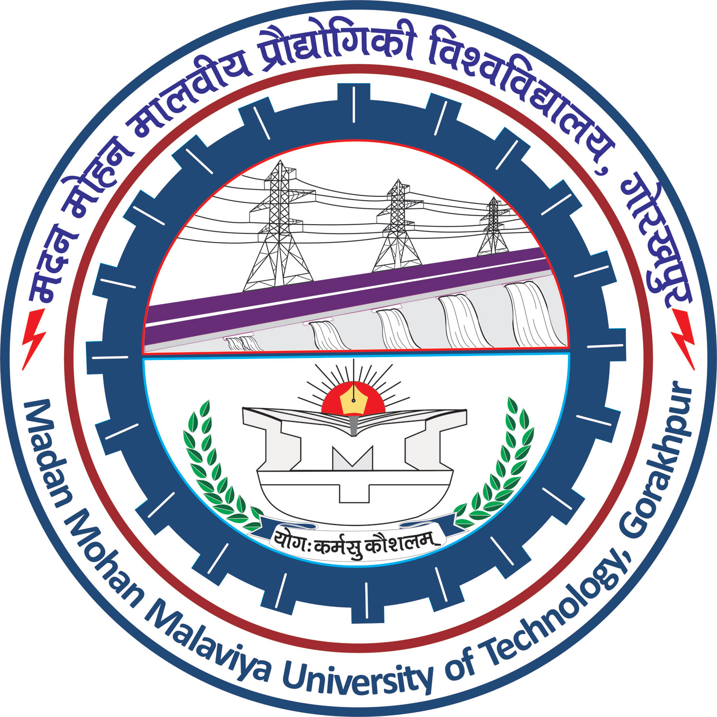

**Application for admission to Doctor of Philosophy (Ph.D.) programme**

**1.** Name in full (in Capital Letters):

**2.** Date of Birth:

**3.** Gender:

**4.** Nationality:

**5.** Permanent Address:

**6.** Present (Local) Address:

**7.** Category:

**8.** Present Occupation/Employment**\***:

(Give Name and Address of the Employer)

**9.** Particulars of Degrees previously obtained (attach attested copies of statement of

marks and certificates):

|  |  |  |  |  |  |
| --- | --- | --- | --- | --- | --- |
| Degree | University | Year of | Subjects | Class | Percentage/ |
|  |  | Passing | Offered | Grade | Grade Points |
|  |  |  |  |  |  |
| High School  Intermediate  Bachelor’s Degree |  |  |  |  |  |
| Master’s Degree  Any other Degree |  |  |  |  |  |

**10.** Particulars of Publications:

|  |  |  |  |
| --- | --- | --- | --- |
| S.No | Title of the Paper/Book | Name of the Journal/ Publisher | Place and Year of Publication |
| 1. |  |  |  |
| 2. |  |  |  |
| 3. |  |  |  |

**11.** Details of Teaching Experience:

|  |  |  |
| --- | --- | --- |
| Name of the University / College | Subject(s) Taught | Year(s) |
|  |  |  |
|  |  |  |

**12.** Details of experience other than teaching if any (Attach necessary certificates):

(i) Nature of Experience:

(ii) The Institute/Industry where experience was gained:

(iii) Period of experience:

**13.** Title of P.G. Dissertation, if applicable

**14.** Awards/Recognition

………………………………….……………………………………………………………….

All the particulars given above are true to the best of my knowledge. I have read the Rules for the Degree of Doctor of Philosophy (Ph.D.) and I undertake to abide by them.

Date:

Applicant

Place:

**\*Note:** No objection certificate from employer to be submitted on organization along with application form.